Central Depository Bangladesh Ltd. www.cdbl.com.bd

Please attach
a passport size photograph

Registration Form for Online Securities Balance Enquiry

Tel: 9137906, 9137469, 9137518, 9137928
e-mail:cdbl@bol-online.com

Please fill up in CAPITAL letters

Date ……/……/..……….
dd mm yyyy

As a BO Account holder you can register for Internet Balance Enquiry by filling in the details below, attaching your passport size photo and sending the completed form dully signed by you to Central Depository Bangladesh Ltd., BDBL Bhaban(18th flr), 12 Kawran Bazar, Dhaka-1215.

The annual Online Securities Balance Enquiry of Tk. 200/- has to be paid with your application for registration which may be in Cash/Cheque (or Demand Draft if your bank account is outside Dhaka) made out in the name of Central Depository Bangladesh Ltd. / SureCash mobile banking by following the payment process

*Your 16 digit BO ID:

*Your 13 digit Bank A/C No:

*Your e-mail address: ………………………………….……………………………………..…

*Your BO Account Name: …………………………………………………………….………………..

*Your Address: …………………………..………………………………………………………….…….

………..……………………………..…Phone:…………………….Mobile:…………...………………..

In case of individual or joint account holder, 1st account holder’s

*Date of Birth: …..../…..../…………..

*Father’s/Husband’s Name (in case of married woman):.…………………………………………………….….

Payment Details
*Paid amount : …………..………………………………………………………….…….

*Payment option : Cash / Cheque (or Demand Draft if your bank account is outside Dhaka) /

SureCash (If SureCash, write down the Txn ID)

*Payment Txn ID : ………………………………………………………….………………..
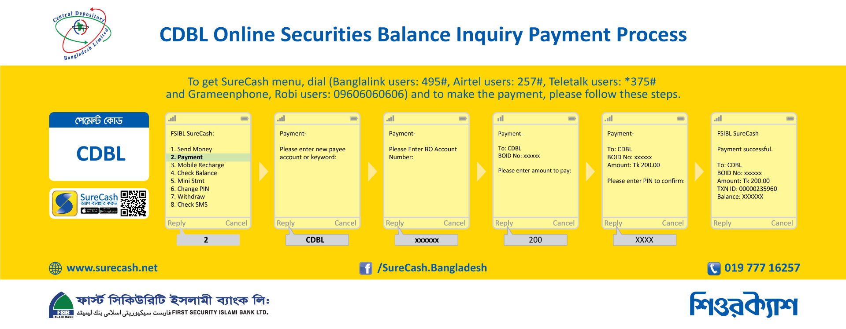CDBL will email your username and password to you as soon as your registration is completed

BO Account Signatory’s Name(s) | Signature(s)
Internet Balance Inquiry from CDBL - Terms & Conditions of Service

1) Internet Balance Inquiry Service

CDBL offers Web based BO Account Balance Enquiry Service to the registered Beneficiary Owner (BO) Accountholders giving details of Share holdings with Portfolio Valuation of their BO Accounts who have subscribed to CDBL’s Balance Enquiry Service by filling in the prescribed Balance Enquiry registration form.

There is an annual internet balance enquiry service fee of Tk. 200

Web balance data will be updated daily at 10.00 am

Internet connection is mandatory to avail this service

Username & password will be sent to the valid email address which is mentioned in the form

2) Internet Balance Inquiry Content

Go to our website www.cdbl.com.bd and enter correct username & password to get the share balance with portfolio valuation. Example of content of Internet Balance Inquiry is given below:
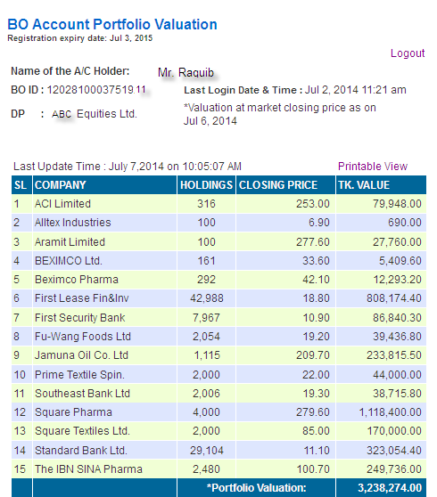

3. Obligations

Any discrepancies or errors in balance inquiry found must promptly be notified to the Depository Participants and CDBL (via email cdbl@bol-online.com).

4. Discontinuation / Termination

Internet Balance Inquiry Service may be discontinued by CDBL for a specific or indefinite period, with or without giving any prior notice for security reasons or system maintenance or for such other reasons as may be warranted at CDBL’s sole discretion. CDBL may also discontinue the Service at any time without specifying any reason or giving any prior notice.

6. Declaration and Signature

I hereby acknowledge that I have read and understood the aforesaid terms & conditions and agree to comply with them.

Full Name Signature date: dd / mm / yyyy

